**Project Analytics - DSTI - 7/7/2024**

**Phuc Nguyen PHAM**

Data Mining & Machine Learning on SAS Viya – BigOrganics Business Case –

First of all, we setup the parameters so they are ready to be trained. 2 variables “DemCluster” and “TargetAmt” will be rejected.

We tried the first data model like this:

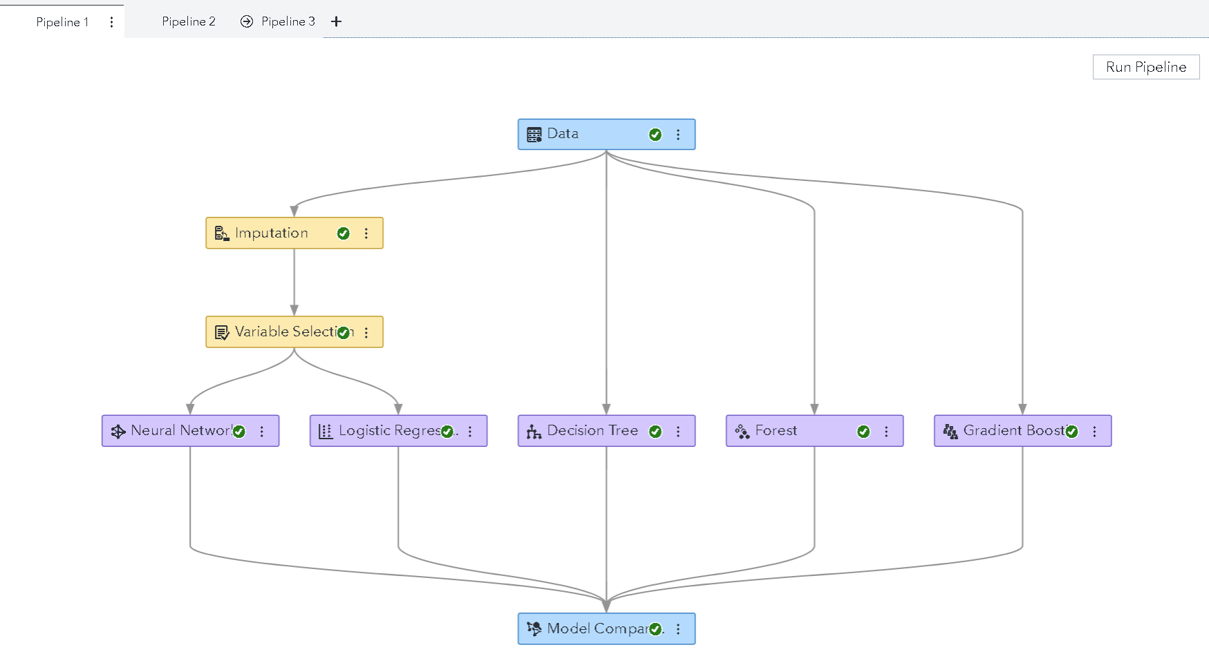

The results show that the Forest gives the highest score with (0.6334).

With the second data model, the result is still the same.

With the third data model, we can see that the forest give a better score (0.6548)

So we conclude that the third pipeline is the best. We did 2 transformation, 1 imputation, 1 ensemble and 1 feature machine. Those help to make a better result.

Ex 2:

First of all, We changed Target Gift Flag as a Category.

Here is the list of predictors that we choose:

Then we create some models.

1. We got the result of 0.1639 (Youden) for the decision tree.

1. For the Bayesian Network, we got 0.499

1. For the Gradient Boosting, we got 0.3488.

1. For the Forest model, we got 0.1563

1. We got the score of 0.1863 for the Logistic Regression.

1. For the Neural Network, we got the score of 0.

1. And finally, we got the score of 0.1783 for the SVM.

Then we build a data comparison tab:

According to the model comparison, Bayesian network is the best model with the Youden score at 0.449, so it will be selected.

We export to the Excel file, then go to the tab “Lift” and create a new column with the formula like this:

=100000*A2/100*(-2+3*F2*50/100)

We choose the formula like it because there is more than 100 000 people in the PVA Table, and there is 50% of people who are likely to do the donation. The cost is 2$. The margin is 3$.

So we can get the result like this:

|  |  |  |  |  |  |  |  |
| --- | --- | --- | --- | --- | --- | --- | --- |
| Percentile | Observations | Events | Model | Best | Cumulative Model | Cumulative Best | ROI |
| 5.00 | 3250 | 3250 | 1.9055 | 1.9055 | 1.9055 | 1.9055 | 4291.577497 |
| 10.00 | 3250 | 3173 | 1.8604 | 1.9055 | 1.8830 | 1.9055 | 8244.554543 |
| 15.00 | 3250 | 2821 | 1.6540 | 1.9055 | 1.8067 | 1.9055 | 10649.64381 |
| 20.00 | 3250 | 2755 | 1.6153 | 1.9055 | 1.7588 | 1.9055 | 12764.50412 |
| 25.00 | 3250 | 2557 | 1.4992 | 1.9055 | 1.7069 | 1.9055 | 14008.67755 |
| 30.00 | 3250 | 2282 | 1.3380 | 1.9055 | 1.6454 | 1.9055 | 14043.56366 |
| 35.00 | 3250 | 2095 | 1.2283 | 1.9055 | 1.5858 | 1.9055 | 13256.13438 |
| 40.00 | 3250 | 1879 | 1.1017 | 1.9055 | 1.5253 | 1.9055 | 11518.86488 |
| 45.00 | 3250 | 1816 | 1.0648 | 1.9055 | 1.4741 | 1.9055 | 9504.558647 |
| 50.00 | 3250 | 1611 | 0.9446 | 1.9055 | 1.4212 | 1.9055 | 6588.783677 |
| 55.00 | 3250 | 1589 | 0.9317 | 0.9446 | 1.3767 | 1.8182 | 3576.265721 |
| 60.00 | 3250 | 1639 | 0.9610 | 0.0000 | 1.3420 | 1.6667 | 783.6181877 |
| 65.00 | 3250 | 1485 | 0.8707 | 0.0000 | 1.3058 | 1.5385 | -2686.23025 |
| 70.00 | 3250 | 1280 | 0.7505 | 0.0000 | 1.2661 | 1.4286 | -7057.54742 |
| 75.00 | 3250 | 1149 | 0.6737 | 0.0000 | 1.2266 | 1.3333 | -12004.9251 |
| 80.00 | 3250 | 1113 | 0.6526 | 0.0000 | 1.1907 | 1.2500 | -17110.6095 |
| 85.00 | 3250 | 891 | 0.5224 | 0.0000 | 1.1514 | 1.1765 | -23192.5185 |
| 90.00 | 3250 | 451 | 0.2644 | 0.0000 | 1.1022 | 1.1111 | -31209.2873 |
| 95.00 | 3250 | 275 | 0.1612 | 0.0000 | 1.0526 | 1.0526 | -40000 |
| 100.00 | 3238 | 0 | 0.0000 | 0.0000 | 1.0000 | 1.0000 | -50000 |

Then we visualize the result:

According to the ROI graph, the maximum of the ROI (which is 14043.56$) is at the percentile of 30%. It means that if we select the 30% who has the highest probability to donate, we must get 14043.56$ back.

Please find the attached to see the project.